David Evans
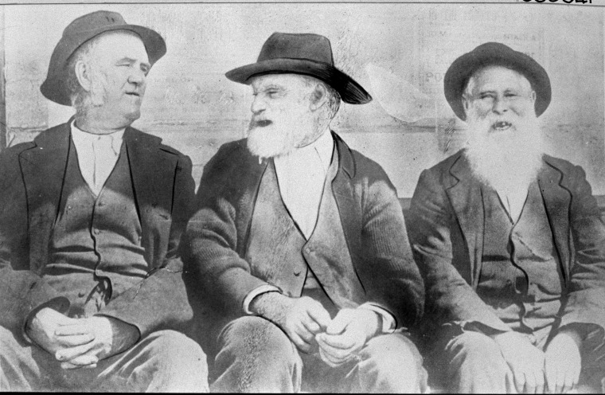
Convicts Tom the dealer (L), Davey Evans (C) and Paddy Paternoster (R)

David Evans was born in Isfield, Sussex on 11 June 1832. The Evans family were farm labourers.
He was the fifth born child to John and Mary Ann Evans (nee Dumbrill). His four older brothers George, John, William and Henry were born in the ten years before David, and his sister Martha was born seven years after him.,
On 14th June 1853, three days after David turned 21, he married Ann Packham in Uckfield, Sussex. David and Ann produced two daughters together, Rosina (b. 1854), and Mary Ann (b. 1857).
On 25th June 1857 David stole 13 sheep and 12 lambs from local butcher and farmer Henry Elphick of Framfield, Sussex. He then sold the sheep at a local market using an assumed name. David was tried for this crime at the Michaelmas session of the Sussex Court of Assize on 19th October 1857. He was sentenced to ten years penal servitude.
In 1858, David’s wife Ann died, leaving their two young daughters without their mother while their father was serving his prison term. The two girls were taken in and cared for by members of the Packham family. Rosina lived with an uncle and aunt from the Packham side, Henry and Frances Stevens. Mary Ann lived with her grandparents, William and Elizabeth Packham.,
David was transported to Western Australia on the ship Palmerston and arrived in the colony in 1861 at the age of 29. The records for the voyage describe David as: 5 feet 4 ¼ inches tall; healthy build; dark brown hair; hazel eyes; thin face; fresh complexion; scar on his left thumb. David was given a ticket of leave on 13th November 1861, and was assigned to work in York, 97 kilometres east of Perth. David was employed cutting sandalwood. Even when on ticket of leave, he donated 2 shillings to a relief fund for those suffering from the Lancashire Cotton Famine in 1863, a depression in the textile industry of North West England, brought about by overproduction.
In 1866, he gave evidence in a case involving the theft of sandalwood by others. David was given a conditional pardon on 3rd June 1865, and then received a certificate of freedom on 2nd December 1867.
In 1869, when he was 37, he married Mary Fleming who was only 16 and had emigrated from Ireland with her parents when she was one. They were married at the Roman Catholic Church in York on 25th November 1869. The pair were to produce twelve children over the following 25 years, with ten sons and two daughters. In order of birth they were: John (b. 1870); William James (b. 1873); David (b. 1874); Elizabeth (b. 1877); Ellen (b. 1880); George William (b. 1882); Frederick Edwin (b. 1884); Matthew Francis (b. 1886); William Henry (b. 1889); Ernest (b. 1890); Albert Victor (b. 1893); and Roy (b. 1894).
Second eldest son William James Evans died when aged just seven days, in 1873.
There were some problems in their marriage as David had to advertise in 1878 that he was no longer responsible for her debts. Shortly before this, Mary had complained to the police that David Evans had threatened to take her life.
The Evans family lived on a farm near the 19 mile inn on the York Road. Evans made extra money by tendering to keep the York Road clear of fallen trees and repairing bridges.
In 1890, both daughters of the Evans family, aged 9 and 13, were sitting in one of the rooms of the family house. One of them turned the wick of a lamp down but it fell into the kerosene and the lamp exploded. The dresses worn by the two girls caught fire and they rushed out into the open air calling for help. That was the worst thing they could do because there was a strong wind outside which fanned the flames. Their mother tried to put out the flames and got burnt herself. Both girls were severely burned and were in dreadful pain. Dr McWilliam came from York and arrived about 10 minutes before the eldest daughter, Elisabeth, died. The other, Ellen, also succumbed.
The house was also damaged. A public appeal was launched for David Evans and 82 donations were received totalling 22 pounds.
David Evans was so touched at the public support he published his “sincere and heartfelt thanks”. He said “I cannot recognise in a lifetime spent in the district one single act of mine which should have merited or demanded such noble generosity.”
David Evans lost another child three years later at the 54 mile tank on the Eastern Railway, in 1893.
Albert Victor Evans did not make it to his first birthday, after being bitten by a snake as a 10-month old. Then David’s wife, Mary Evans was to encounter complications in trying to give birth to the couple’s twelfth child. Both mother and baby son died on 16th September 1894 in the attempt. Mary was 41 years of age.
David was unable to care for the children following demise. David’s eldest son John was married with a young daughter at the time of Mary’s passing, and he and his wife Elizabeth agreed to take in David and Mary’s youngest son Ernest, and to raise him as their own. Ernest, the sixth child of David and Mary Evans died in France during World War I at the First Battle of Bullecourt on 11th April 1917, aged just 26. The next three youngest of David and Mary’s sons, Frederick, Matthew, and William were all sent to the Swan Boys’ Orphanage. The older Evans boys went striking out on their own.
David Evans went on to outlive his much younger wife Mary by 18 years. He finally died of cardiac failure in York on 18th March 1912, at the age of 79.

David died on 18 March 1912.
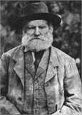
David Evans

A paper researched and written by
Luke Bassett
and
Rob Garton Smith
President
The York Society (Inc)
February 2022

These notes borrow freely from the biography of David Evans researched and written by Luke Bassett in order to present a composite biography.
1898, picture, State Library of Western Australia, slwa_b2462917_1.
Biography of David Evans by Luke Bassett
Registers of Births, Marriages and Deaths for Evans sons.
Birth Index entry for Martha Evans, December quarter 1840, Uckfield, Sussex, England, Civil Registration volume 07 page 421.
Marriage Index entry for David Evans and Ann Packham, June quarter 1853, Uckfield, Sussex, England, Civil Registration volume 2b Page 135, FreeBMD England and Wales Marriage Index 1837-1915.
Birth Index entry for Rosina Evans (June quarter 1854) and Mary Ann Evans (March quarter 1857), Uckfield, Sussex, England, Civil Registration volume 02B page 103, General Registrar Office UK.
Transcript of trial of David Evans on 19 October 1857, Jenny Comben to Luke Bassett email.
Return for trial of David Evans on 19 October 1857, England & Wales Criminal Registers, 1791-1892, Class: HO 27; Piece: 118; Page: 258.
Death Index entry of Ann Packham, September quarter 1858, Uckfield, Sussex, England, Civil Registration volume 2b page 54.
1861 England Census entry for Rosina Evans, Class: RG 9; Piece: 575; Folio: 83; Page: 19; GSU roll: 542665.
1861 England Census entry for Mary Ann Evans, Class: RG 9; Piece: 576; Folio: 9; Page: 12; GSU roll: 542665.
Physical description of David Evans, State Records Office of Western Australia, Convict Lists and Registers, 1850-1868, Acc 128, AN358, Convict Register Number 5770.
Inquirer and Commercial News, 11 March 1863, p.4.
Inquirer and Commercial News, 11 April 1863, p.3.
Convicts in Western Australia.
Marriage Certificate for David Evans and Mary Fleming, married 25 November 1868, Registry of Births, Deaths & Marriages Western Australia, 2994/1869.
Birth Index entries for Evans children: John (12748/1870); William James (14964/1873); David (16068/1874); Elizabeth (17847/1877); Ellen (20687/1880); George William (22727/1882); Frederick Edwin (25187/1884); Matthew Francis (28351/1886); William Henry (87/1889); Ernest (1358/1890); Albert Victor (277/1893); and Roy (NA/1894), Registry of Births, Deaths & Marriages Western Australia.
Death Certificate for William James Evans, died 29 August 1873, Registry of Births, Deaths & Marriages Western Australia, 6782/1873.
Eastern Districts Chronicle, 2 March 1878, p.4.
Eastern Districts Chronicle, 23 February 1878, p.2.
Eastern Districts Chronicle, 12 May 1888, p.5; 9 June 1888, p.5; 16 February 1889, p.5; 13 April 1889, p.7; 8 June 1889. P.5; 13 July 1889, p.3.
West Australian, 1 January 1890, p.3; Eastern Districts Chronicle 4 January 1890, p.4, 9 January 1890, p.8, 18 January 1890, p.4; WA Record 23 January 1890, p.8, 30 January 1890, p.7; Eastern Districts Chronicle 1 February 1890, p.4.
Eastern Districts Chronicle 18 January 1890, p.4.
Eastern Districts Chronicle 8 February 1890, p.7.
Inquirer and Commercial News 15 December 1893, p.17.
Death Certificate of Albert Evans, died 1 December 1893, Registry of Births, Deaths and Marriages Western Australia, 977/1893.
Death Certificate for Albert Victor Evans, died 1 December 1893, Registry of Births, Deaths & Marriages Western Australia, 977/1893.
Death Certificate for Mary Evans, died 16 September 1894, Registry of Births, Deaths & Marriages Western Australia, 773/1894.
Lindsay Watson, via email to Luke Bassett.
WWI Service Record for Ernest Evans.
Lindsay Watson to Luke Bassett email.
Death Certificate for David Evans, died 19 March 1912, Registry of Births, Deaths & Marriages Western Australia, 11/1912.
Biography of David Evans by Luke Bassett
Photo of David Evans, Jenny Comben to Luke Bassett email.

