The Streets of York

Redmile Road
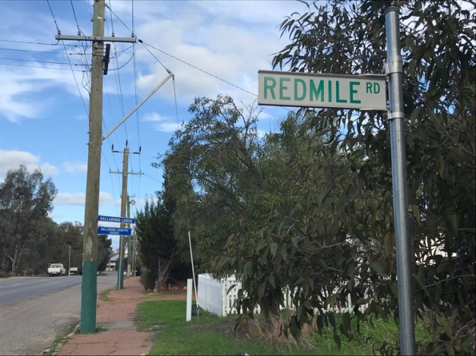

Charles Redmile (1818-1898) and Sarah Redmile ( née Naylor 1820-1910) married in Boston, Lincolnshire in 1844 and migrated to Western Australia with their son Elijah in the same year. They built their home Riverview House in approximately 1853 (later known as Redmile House) on Redmile’s Lane which was later called Bridge Street and later again Redmile Road. They ran a trading post in Brook Street for 15 years, outfitting expeditions and selling general stores from a premises previously occupied by Mr. O. Sargent before they commenced farming at a homestead on the eastern side of York.
Their daughter Sarah Ann Redmile married Stephen Hogan Jnr. A relationship that was apparently not approved of by her parents, local folklore suggesting that the couple eloped. A rhyming ditty sung by local children for many years tends to support this theory

“Dark & dreary was the night
For there was talk of slaughter
When Stephen Hogan ran away with
Grandmother’s Redmile’s daughter”.

Charles died in 1898 and Sarah passed away in 1910 at her residence, Mount Brown House, after falling down a flight of stairs. They are buried with their daughter Sarah Ann Hogan in the same grave in the Anglican section of the York Cemetery.

For many years pedestrians could only reach the other side of the river at Redmile’s Lane through the generosity of Mr Parker who allowed public access via his land. A temporary bridge across the Avon River was constructed there in 1853 but it was not a popular site, was too narrow for carts and soon fell into disrepair. The lane was the main access to the convict depot and also the main York thoroughfare despite being only 220 yards long and very narrow, and there were many bitter complaints about its condition over many years. In 1856 a complaint to the Colonial Secretary mentioned holes filled with mud resulting in teams becoming bogged and capsizing. In 1858 the government sought permission from the owners of the land John Larter, Charles Redmile and Joseph Kenworthy to give up the necessary land to widen the lane. Clay bricks made from the mud were used in the building of the new courthouse.

