CONVICTS WHO BUILT YORK
Joseph Nunan / Noonan
The last convict ship to arrive in Fremantle was the ‘Hougoumont’ in 1869. It carried two hundred and fifty convicts including sixty two Fenians. Seventeen of these prisoners were military Fenians. This was unusual as it was British Government policy not to transport political prisoners. Their presence meant there was a higher percentage of literate prisoners. The escape of some of these Fenians in the ‘Catalpa’ has been related in a number of books but many stayed in Western Australia and some going to the Eastern States, to America or returning to Ireland.
Joseph Nunan was born in 1842 in the village of Rathcormac, County Cork, Ireland to parents Denis and Jane nee Murphy. He learnt his building trade from his father Denis, who, with his brother Frank, had a successful building company that constructed buildings locally and in County Kerry.
In 1864 Nunan became a member of the Irish patriot organisation the Fenian Brotherhood. The organisation was trying to establish a ‘free’ Ireland not under the rule of Great Britain. A Fenian rising in February 1867 near Glenbeigh resulted in a shooting of a police constable. Nunan was identified as a suspect and he fled to the mountainous area near the Killarney lakes before taking a ship to London. After about four weeks of freedom he was arrested by an Irish policeman. On the return train trip to Dublin he jumped through the window of a moving train but was once again apprehended near Atherstone and taken back to Ireland.
Nunan’s trial took place on July 27th 1867 in the town of Tralee and after deliberation by the jury he was sentenced to transportation to Western Australia for seven years. The jury delivered a verdict of guilty but recommended mercy as Nunan had not appeared to be a leader in the shooting.
Nunan was transferred to the Portland prison prior sailing in the Hougoumont on 12th October,1867. The civilian Fenians were allocated their own quarters on the ship and soon after gave musical and dramatic performances for the other convicts. They also produced seven issues of a handwritten newspaper called ‘the Wild Goose’. Nunan’s contribution was an article in the first issue which gave an account of his escape, recapture and trial which he entitled ‘Leap for Liberty’. He also organised social events for his fellow convicts.
On arrival at Fremantle on 9th January 1868, Nunan was given convict number 9837 and was described as being 5 foot 8 inches tall with brown hair, blue eyes, a long face, fresh complexion and a healthy appearance.
After a short period of detention in the newly built Fremantle prison Nunan and nineteen other Fenians were sent to the Clarence Road party four miles south of Fremantle. Following conflict between the party and the assistant warder some of the party were returned to the Fremantle prison. It appeared that Joseph remained in the prison for several months during which time he wrote six letters home. On 14th May, 1869 Nunan, along with thirty four Fenians, was granted a pardon and it was at this time that the authorities changed the spelling of his surname to Noonan.
Soon after, Joseph and a fellow Fenian Hugh Francis Brophy set up a building and joinery firm with an office in Pier St, Perth. Although both maintained their Fenian views it seemed the mainly Protestant community of Perth were impressed with their building and design skills and they were contracted to work on a variety of building projects.
The first major project in 1870 was the granting of a government contract to build the Greenough Flats Police Station. This was designed by Richard Roach Jewell. Noonan and Brophy employed many ticket -of leave men with as many as eleven engaged by the partners in various trades during the years 1869 and 1871. Noonan quickly built a reputation as a skilled architect and designer.
Noonan and Brophy also completed the building of the St Mary’s Convent of Mercy (designed by Jewell) in Victoria Square in 1871.
On 21st June 1871 Noonan married Anne Ursula Maria Farrelly who was the daughter of Caroline and Terence Farrelly a well-respected and affluent family in the Perth community.
Hugh Brophy left for Melbourne midway through 1872 but Noonan kept the business flourishing and he continued to employ ticket-of leave men until at least 1879. As many as twelve Fenians were employed for varying periods of time.
A full record of Noonan’s work may never be fully established but it is known that he was responsible for the police station buildings at Roebourne and Cossack between 1875 and 1878 and for extensions to the Champion Bay Jetty in 1872-3. He drew up the plans for the Perth Town Hall, St Mary’s Convent and Cathedral in Perth, Edmund Hall in Christian Brothers College Fremantle and the second Wesley Chapel in Guildford. He also built a store and house for Walter Padbury near his flour mill in Guildford.
His most acclaimed building was the design and building of St Patrick’s Church in York. Father Patrick Gibney the new resident priest in York approached Noonan to build a larger church for the growing Catholic population. At the time of the building York was the fourth largest town in Western Australia.
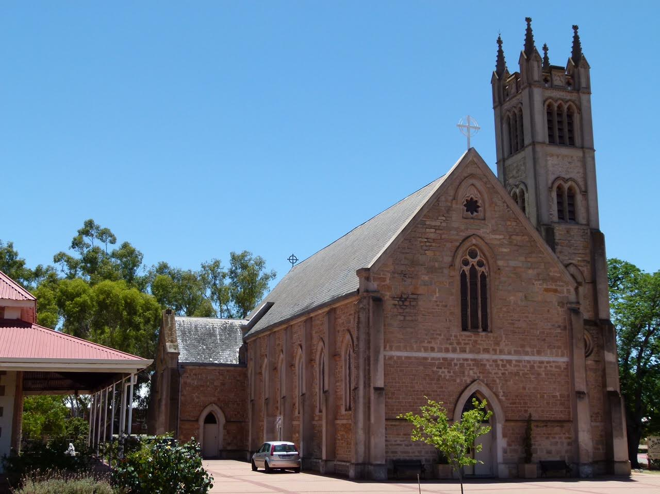
The foundation stone was laid on St Patrick’s Day (March 17th) by Bishop Matthew Griver in 1855, and building commenced in 1875. Noonan’s design was of Victorian Academic Gothic style made using stone and brick with a four level tower. Building materials such as timber, lime, stone and bricks were collected and transported to the site by parishioners ( many of these being ex-convicts ) and even Gibney was recorded as carting timber and contributing three hundred and twenty two days of labour. With the church costing eight thousand pounds the eight hundred parishioners not only donated materials and labour but also conducted a variety of fund raising events over many years.
One such event was a musical evening which was reported in the Eastern Districts Chronicle on Saturday 4 May 1878 regarding entertainment from a group called ‘The Catholic Minstrels’. The performers included Joseph Nunan who sang a song ‘Erin Mavourneen’ and followed this by a rendition of ‘The Irish Emigrant’.
Thomas and Henry Davey, both master stonemasons and bricklayers, were contracted as builders and by May 1877 their work was sufficiently advanced for tenders to be called for the roof. The roof was constructed with thousands of sheoak shingles made under the supervision of Thomas Tompkinson. The beautiful stained glass windows which cost three hundred and thirty pounds were reputed to have been made by Franz Mayer and Co of Munich and Italy.
An inaugural blessing and opening of the unfinished church was held in January 1883 by the brother of Father Gibney, Bishop Matthew Gibney. Sadly Joseph Nonoon was not present when the church was dedicated to St Patrick in February 1886 by Rosendo Salvado.
Joseph contracted tuberculosis in the early 1880’s and died at his home in Howick St, Perth on the 18th of May,1885 aged 43 years having never given up his Fenian beliefs.
Joseph had desired to return to Ireland to die and despite his brothers making arrangements for this to occur his consumption was too advanced to permit this journey. He was buried in the Roman Catholic section of the East Perth Cemetery and an impressive marble monument bears the inscription;
In Affectionate
Remembrance
Of Joseph Denis Nunan
Of Rathcormack, Ireland
Who Died at Perth May 18 1885
Age 43 Years
Requiescat In Pace
Six of his buildings still stand today (2022) with St Patrick’s Church York (now heritage listed) being the finest example of his work. One admirer described this building as a ‘gem of pure Gothic architecture’. Joseph Noonan deserves greater recognition for his role in the many fine buildings in W.A. and it is disappointing that he possibly never realised his full potential with his death at such a young age.

Author Margaret Sermon
September 2022.

